**Assignment 1**

Perform the following operations:

i)                    Create three directories named letter, report and assignment

ii)                  Move to directory letter

iii)                Create two directories named friendly and formal under letter directory

iv)                Move to directory report using only one command (from directory letter)

v)                  Create three directories called personal business school under the directory report (Use only one command)

vi)                Create a directory called unit under the assignment directory without moving from the report directory

vii)              Move to your home directory

viii)            Recursively list all the directories you have created and draw the directory structure

i.



ii.

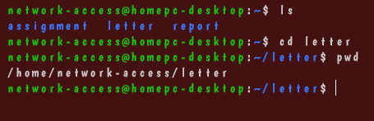

iii.

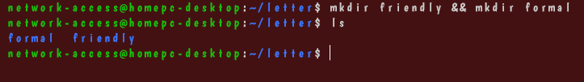

iv.



v.



OR

mkdir {personal,business,school}

vi.

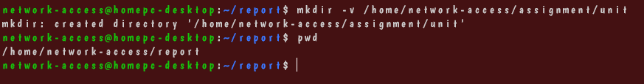

vii.  


viii.

